Visual Verification
A Conceptual Overview

General Notes
Visual Verification (VV) verifies whether screen content (a snapshot) is within the tolerances of a reference snapshot. The core VV terminology is:
- Snapshot: A pixel buffer used for representing and evaluating screen image data.
- Verifier: An oracle object which determines whether a snapshot passes against specified inputs.
- Actual: The snapshot being evaluated.
- Master: The reference data (image) which is used to evaluate the actual snapshot.
- Tolerance: The accepted bounding range based on which the actual snapshot will be accepted as valid.

Verifier Technology
TestApi provides the following Verifier technology:
- SnapshotColorVerifier. Reports passing if every pixel of the verified image is within a user-specified tolerance range of a target color.
- SnapshotHistogramVerifier. Reports passing if the histogram of the image falls under the curve of a reference image histogram. This technique is helpful for allowing small quantities of noise pixels in an image that is otherwise identical to the master image.
- SnapshotToleranceMapVerifier. Reports passing if the every pixel of the verified image has lower color values than the corresponding pixel in the “tolerance map”.

Example
The basic scenario for Visual Verification is to capture window content and compare it against a known image. The diagram below outlines the overall sequence when using a SnapshotColorVerifier verifier:
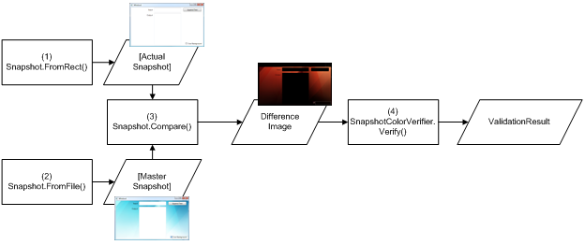
Figure 1 - Sample Visual Verification workflow using SnapshotColorVerifier

The steps for performing the workflow are outlined in the following procedure:

// 1. Capture the actual pixels from the bounds of the screen rectangle
Snapshot actual = Snapshot.FromRectangle(someRectangle);

// 2. Load the reference/master data from a previously saved file
Snapshot master =
Snapshot.FromFile(Path.Combine(TestContext.TestDeploymentDir, "Master0.png"));

// 3. Compare the actual image with the master image
// This operation creates a difference image. Any regions which are identical in
// the actual and master images appear as black. Areas with significant
// differences are shown in other colors.
Snapshot difference = actual.CompareTo(master);

// 4. Configure the snapshot verifier - It expects a black image with zero
// tolerances
SnapshotVerifier v = new SnapshotColorVerifier(Color.Black, new ColorDifference());

// 5. Evaluate the difference image
VerificationResult result = v.Verify(difference);

The above sample demonstrates the simplest possible verification strategy. SnapshotHistogramVerifier and SnapshotToleranceMapVerifier provide more advanced strategies for visual verification.

